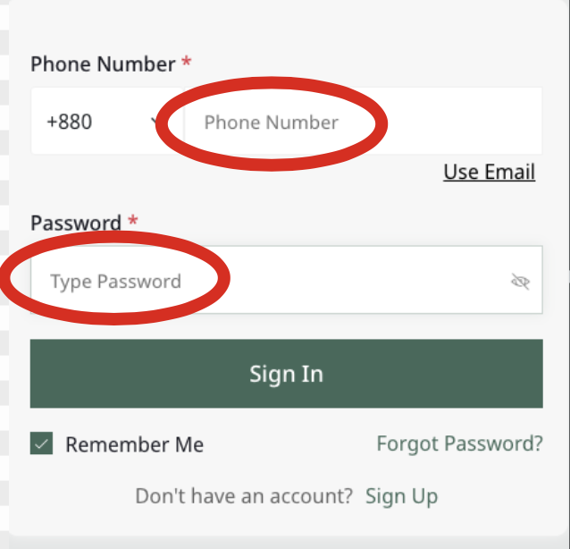

**Bug 1 - DEV Comment: SOLVED**

**Location: Vendor Sign In**

**Issue:**

1. “Phone Number” should be “Enter Phone Number”
2. “Type Password” should be “Enter Password”

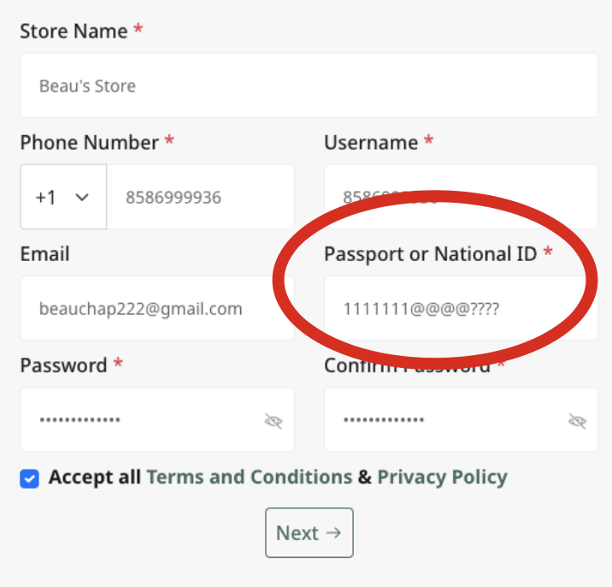

**Bug 2- DEV Comment: SOLVED**

**Location: Vendor Sign Up**

**Issue:**

1. User is able to use special characters in the “Passport or National ID” field

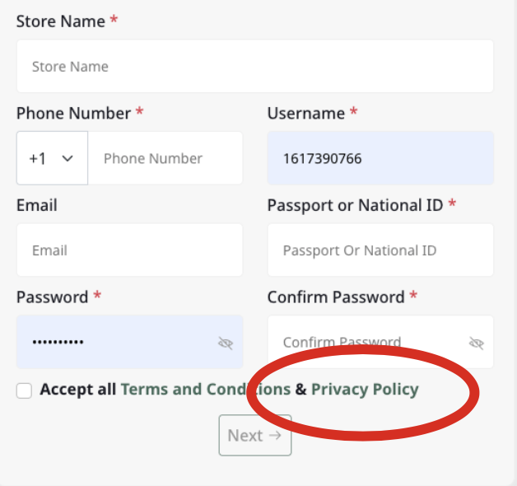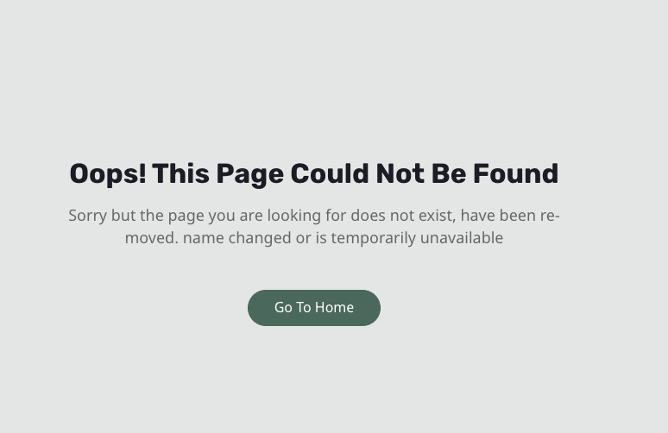

**Bug 3- DEV Comment: SOLVED**

**Location: Vendor Sign Up**

**Issue:**

1. “Privacy Policy” redirect link leads to unavailable page

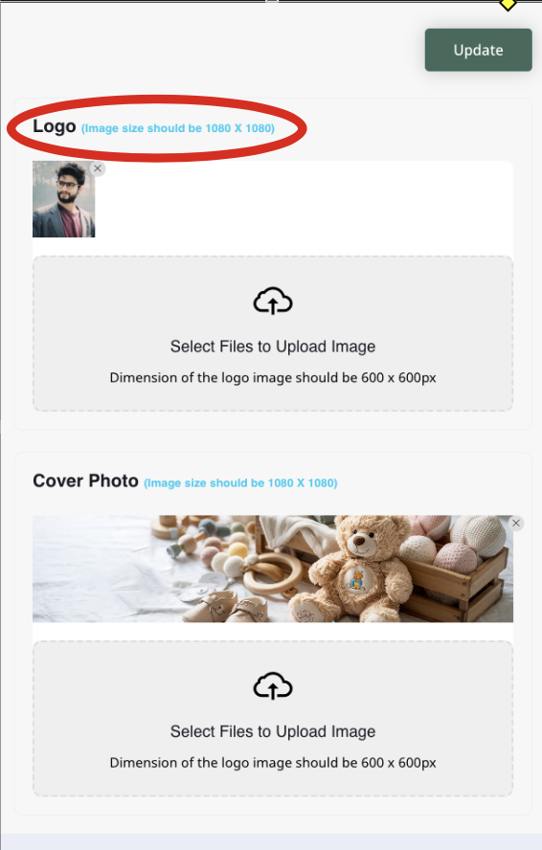

**Bug 4- DEV Comment: SOLVED**

**Location: Profile tab > Basic Info**

**Issue:**

1. “1080 x 1080” should include “px” (pixels) like how it does for the image uploads at the bottom of this screenshot

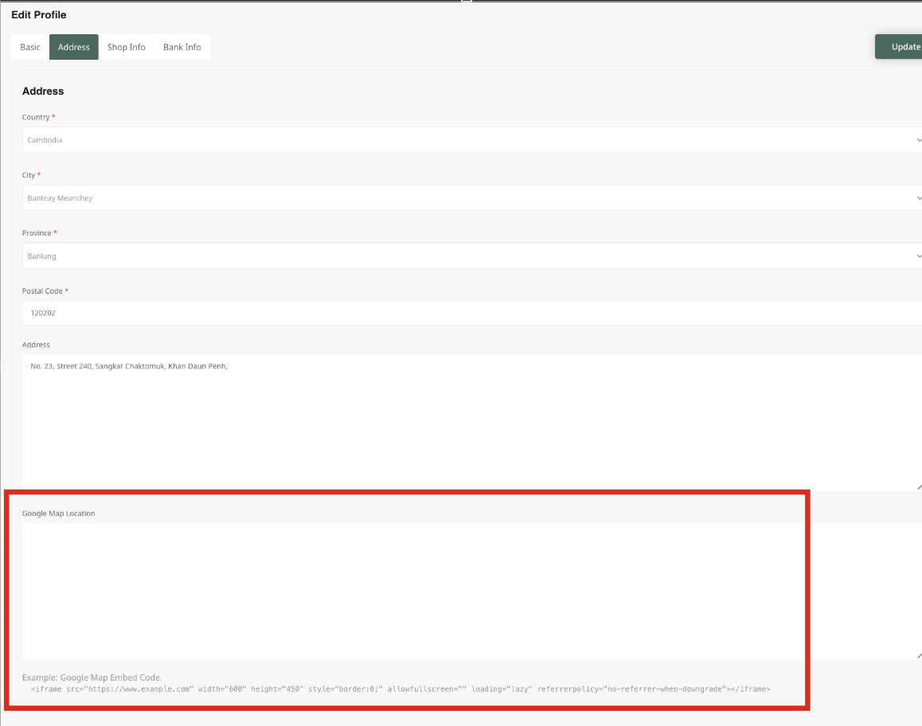

**Bug 5- DEV Comment: SOLVED**

**Location: Profile tab > Address**

**Issue:**

1. Google map not implemented into this page.
2. User cannot pinpoint exact location

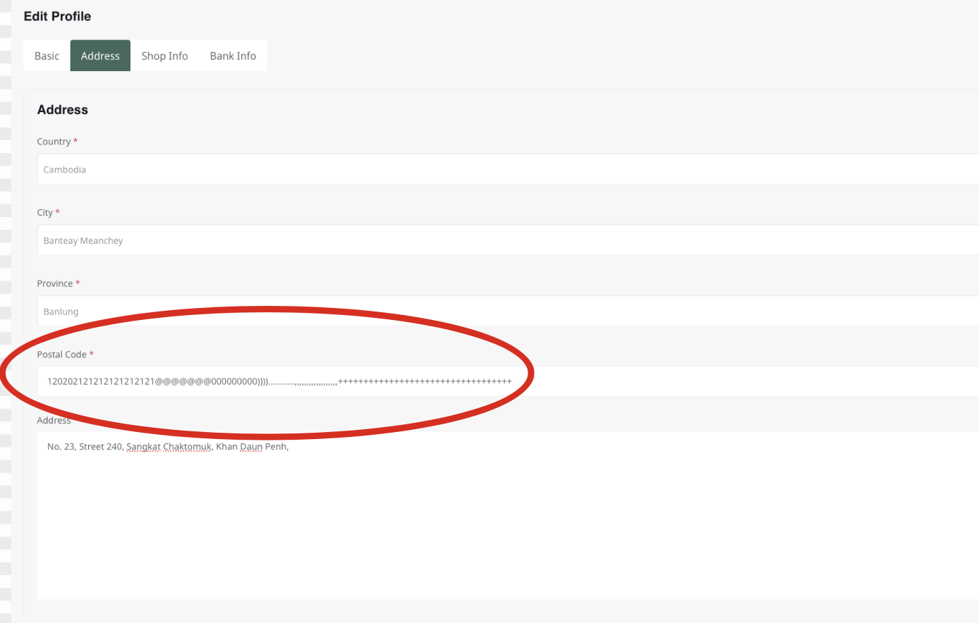

**Bug 6 DEV Comment: SOLVED**

**Location: Profile tab > Address**

**Issue:**

1. No character limit for the Postal Code text field
2. Special characters allowed
3. Letters allowed, should only be numbers

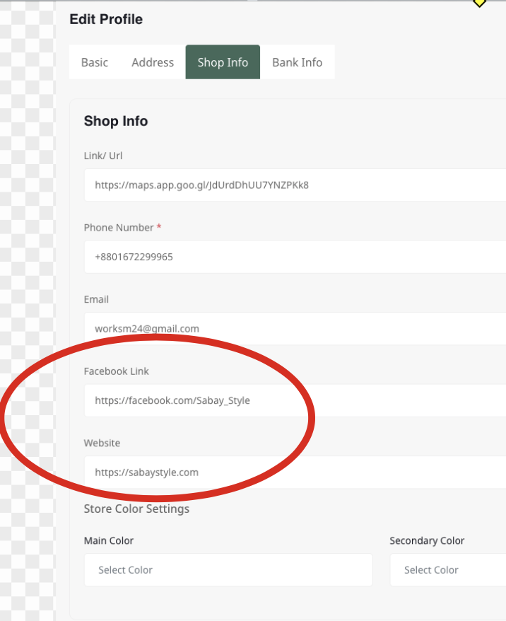

**Bug 7- DEV Comment: SOLVED**

**Location: Profile tab > Shop Info**

**Issue:**

1. “Website” should be changed to “Website Link” like how it says “Facebook Link” above

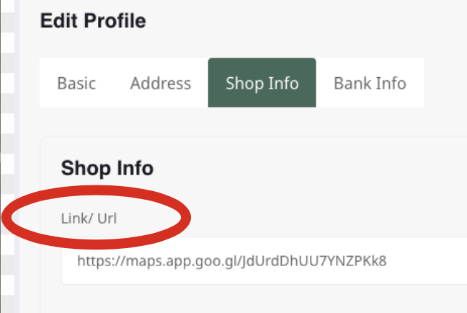

**Bug 8- DEV Comment: SOLVED**

**Location: Profile tab > Shop Info**

**Issue:**

1. There’s an unnecessary space between the dash and “Url”
2. “Url” should be capitalized to “URL” here and for the rest of the dashboard that it reappears.

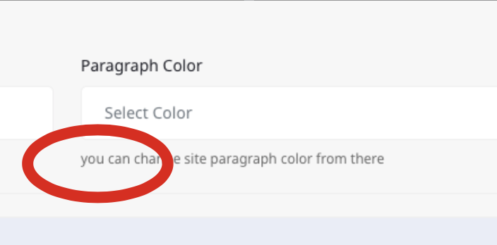

**Bug 9- DEV Comment: SOLVED**

**Location: Profile tab > Shop Info**

**Issue:**

1. “You” needs to capitiliized
2. “The” needs to be added between “change” and “site” so that the whole sentence reads
3. “Can” should be changed to “may”
4. “There” should be changed to “here”
5. “You can change the site paragraph color from there”

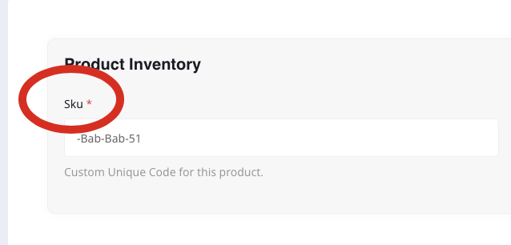

**Bug 10- DEV Comment: SOLVED**

**Location: Inventory > Click on the edit button of a specific product > under the “Product Inventory” title**

**Issue:**

1. “SKU” should be capitalized

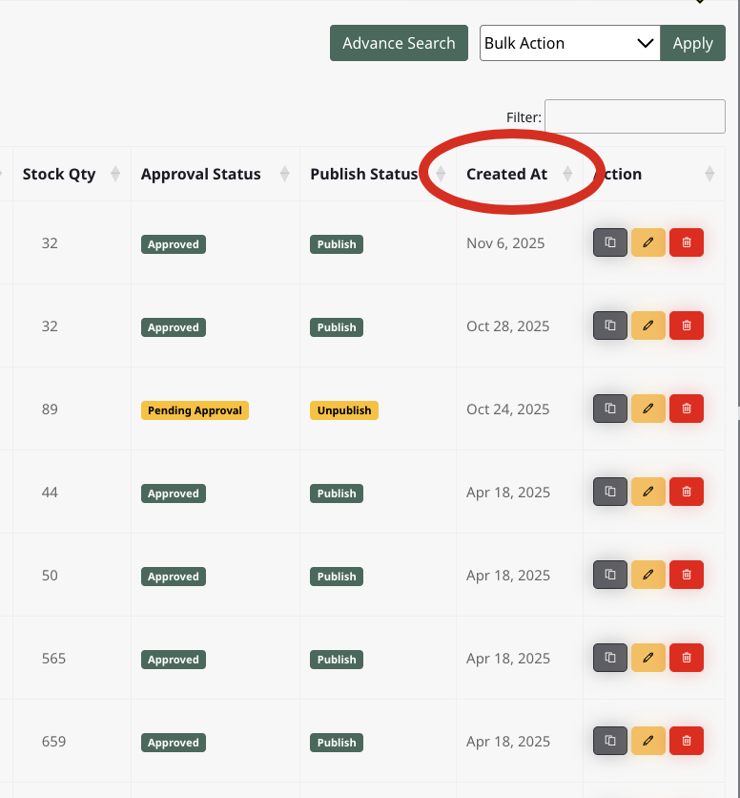

**Bug 11- DEV Comment: SOLVED**

**Location: Products**

**Issue:**

1. “Created At” should be changed to “Created On”

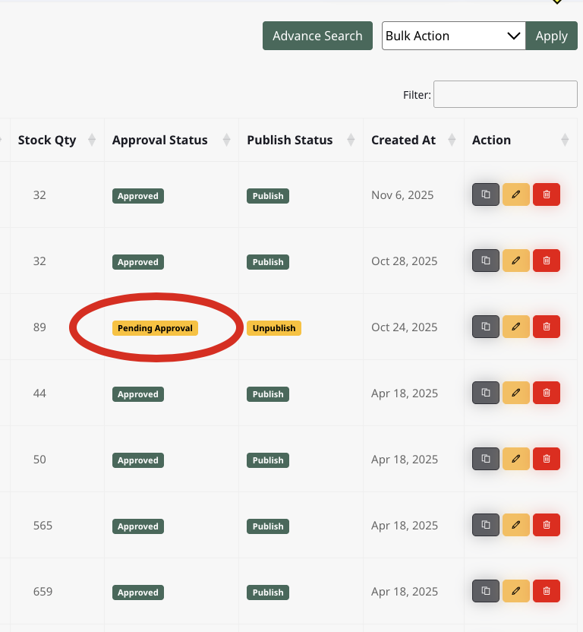

**Bug 11 (recommendation, not bug) - - DEV Comment: IT Was done based on a previous request**

**Location: Products**

**Issue:**

1. “Pending Approval” should be changed to “Pending”

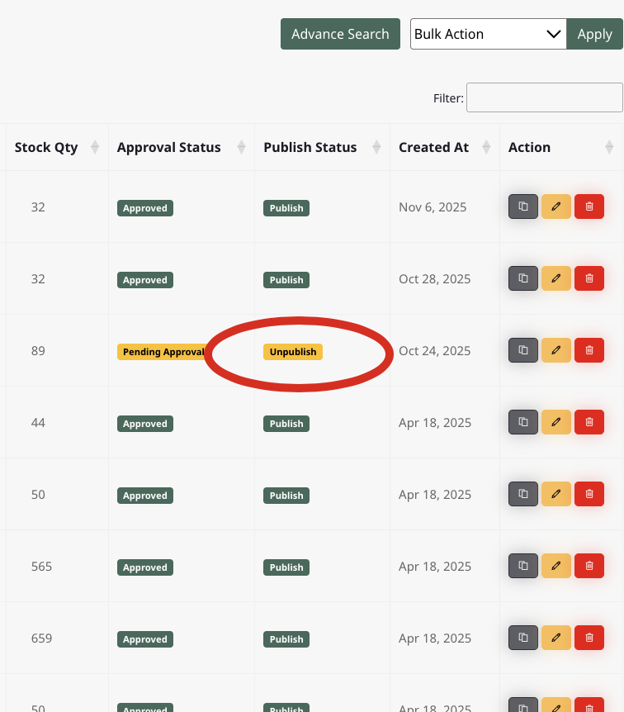

**Bug 12 DEV Comment: SOLVED**

**Location: Products**

**Issue:**

1. “Unpublish” should be changed to “Unpublished”
2. “Publish” should be changed to “Published”
3. “Unpublish” and “Publish” are a verbs

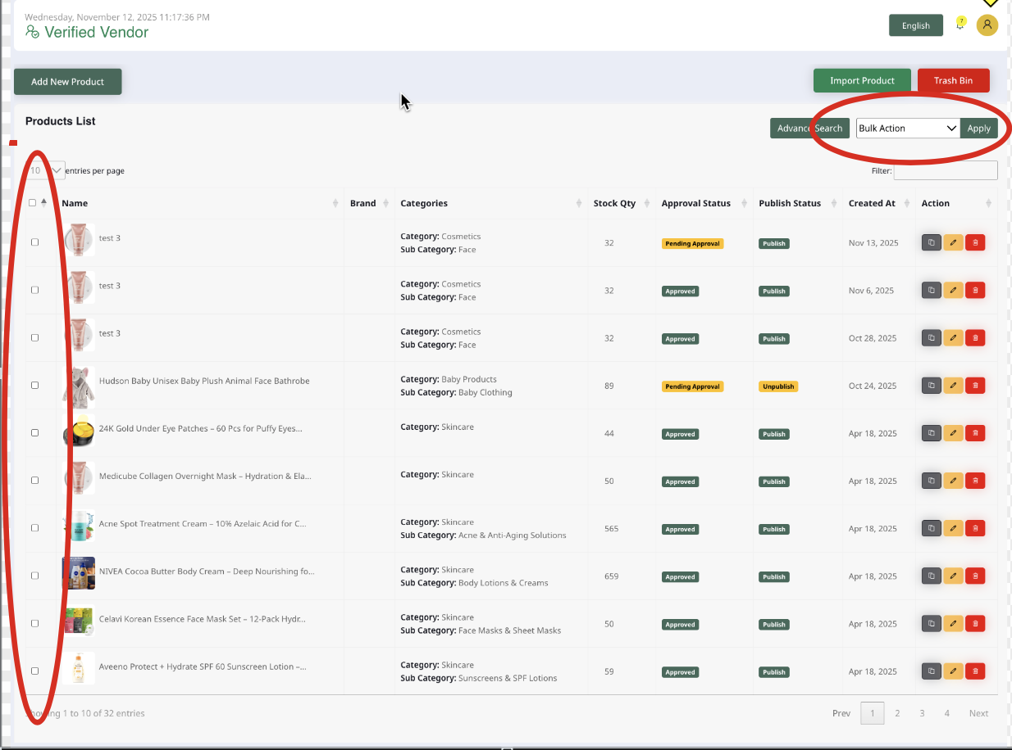

**Bug 13 DEV Comment: SOLVED**

**Location: Products**

**Issue:**

1. Bulk action applies when clicking the trash icon of one individual product
2. All products are deleted instead of the individual product

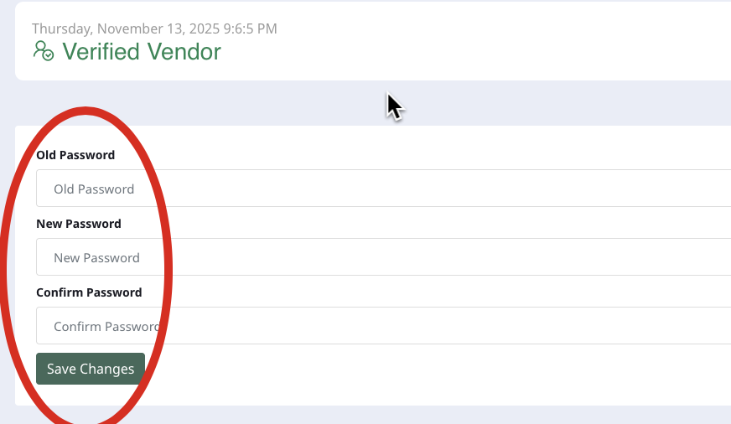

**Bug 14- DEV Comment: SOLVED**

**Location: Vendor Dashboard > Profile Icon > Change Password**

**Issue:**

1. “Old Password’, “New Password”, “Confirm Password” should start with “Enter Old Password”, “Enter Password”, “Confirm Password”

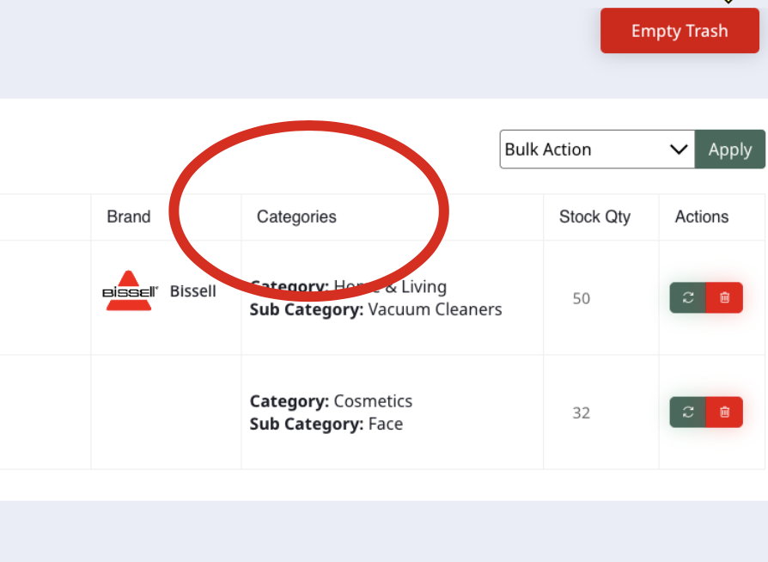

**Bug 15- DEV Comment: IT Outputs both category and sub category at once, that’s why it’s saying categories**

**Location: Vendor Dashboard > Products > Trash Bin**

**Issue:**

1. “Categroies” should be changed to “Category”

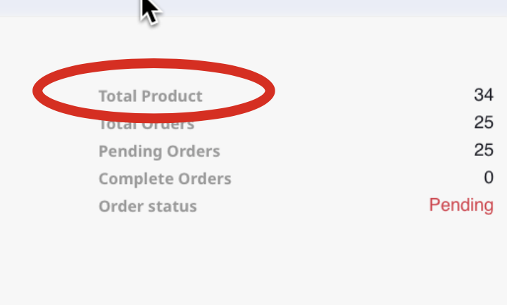

**Bug 16- DEV Comment: SOLVED**

**Location: Vendor Dashboard > Order List > Action List**

**Issue:**

1. “Total Product” should be changed to “Total Products” with an “s” at the end

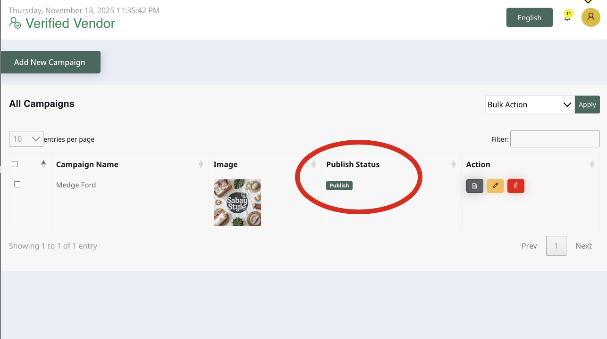

**Bug 17- DEV Comment: SOLVED**

**Location: Campaigns > All Campaigns**

**Issue:**

1. “Publish Status” should be changed to just “Status”
2. “Publish” should be changed to “Published” or “Unpublished” (Publish is a verb)

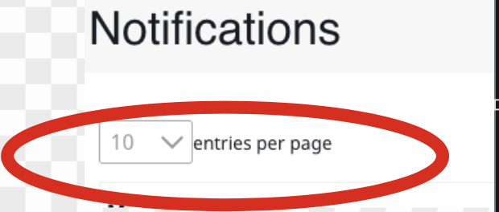

**Bug 18- DEV Comment: Coming From Library- Will deal with this later**

**Location: Notifications icon > See All Notificaiton > Notification**

**Issue:**

1. There should be a space before "entries"
2. Improper alignment

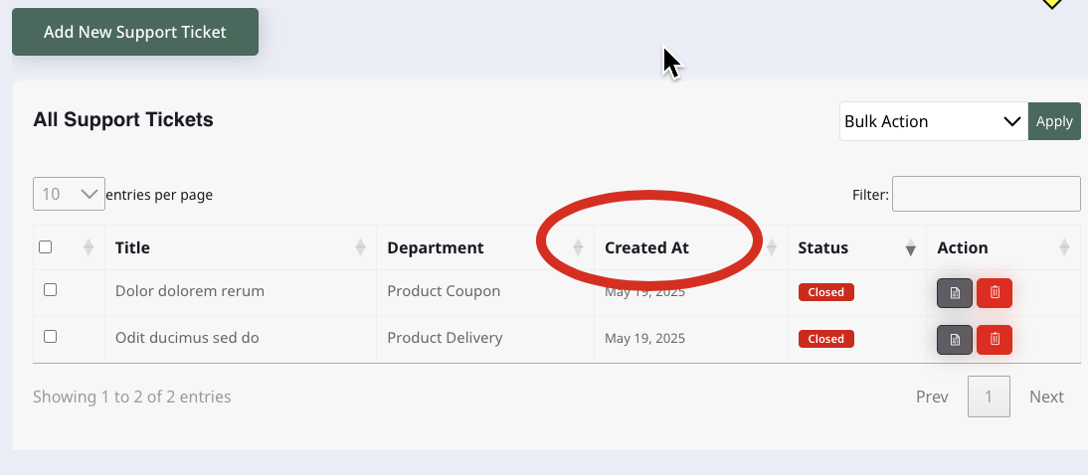

**Bug 19- DEV Comment: SOLVED**

**Location: All Support Tickets**

**Issue:**

1. “Created At” should be changed to “Created On”

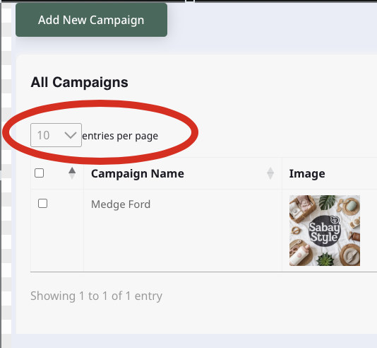

**Bug 20- DEV Comment: Coming From Library- Will deal with this later**

**Location: All Campaigns**

**Issue:**

1. There should be a space between the entries drop down and the word “entries”

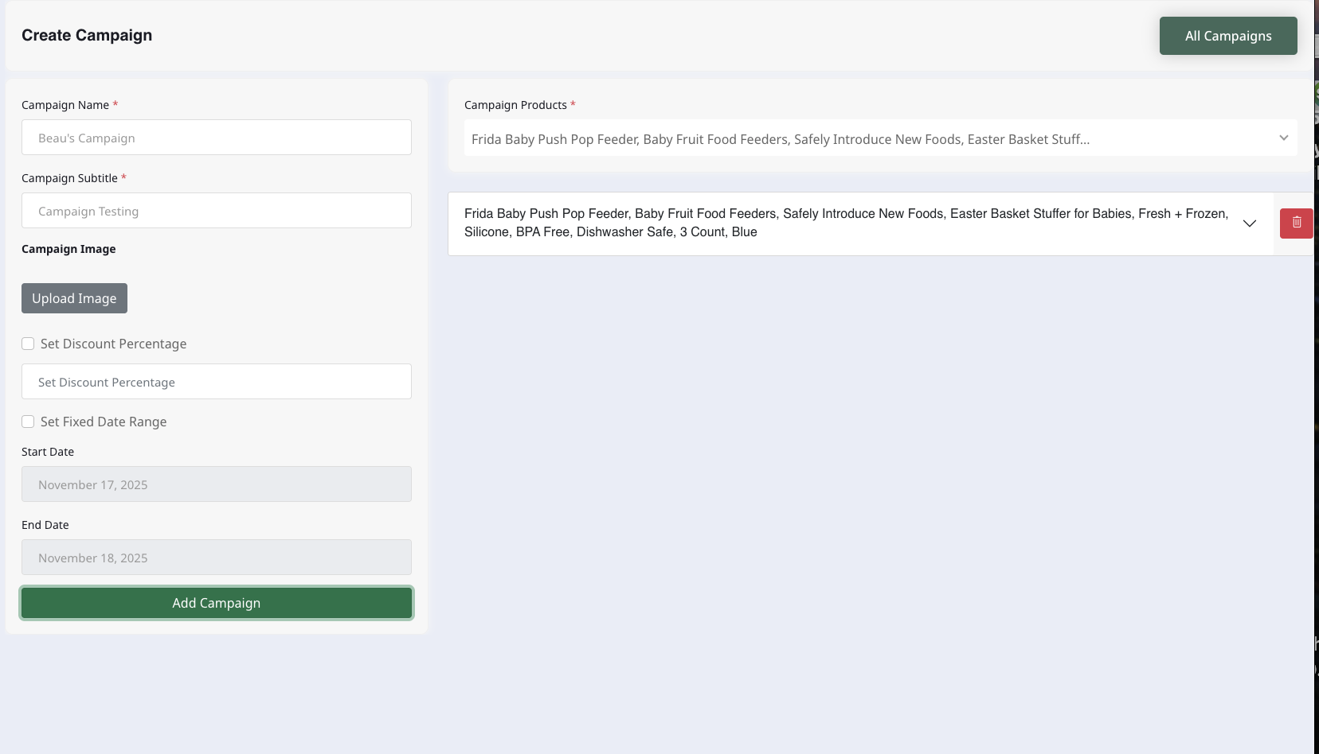

**Bug 21- Check done (dev-nht)**

**Location: Create Campaign**

**Issue:**

1. Page is unresponsive when clicking “Add Campaign” to create a new campaign (No notification or action is followed)

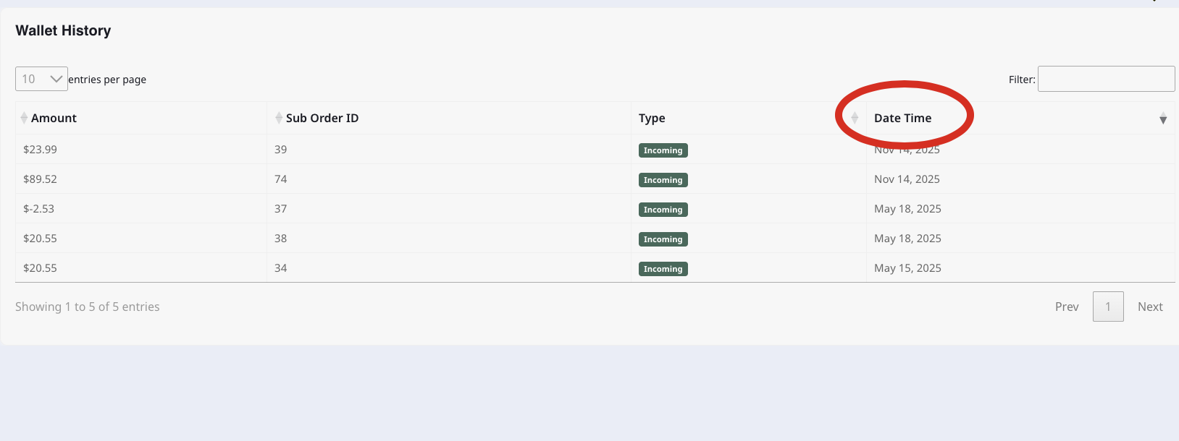

**Bug 22- DEV Comment: SOLVED**

**Location: Wallet HIstory**

**Issue:**

1. “Date Time” should be changed to just “Date”
2. No time is displayed in this column

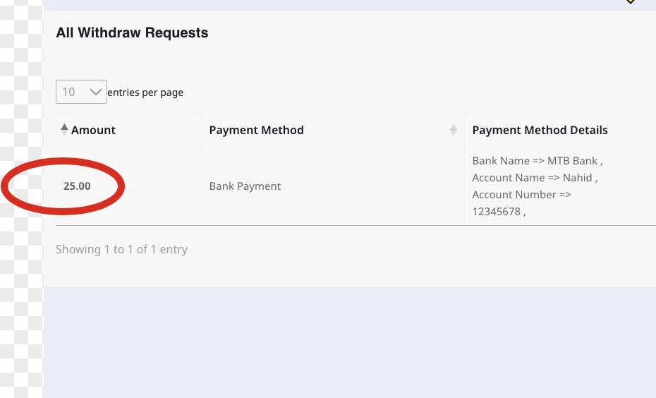

**Bug 22- DEV Comment: SOLVED**

**Location: All Withdraw Requests**

**Issue:**

1. A dollar symbol ($) should be added before the “25.00” to keep a consistent format throughout dashboard

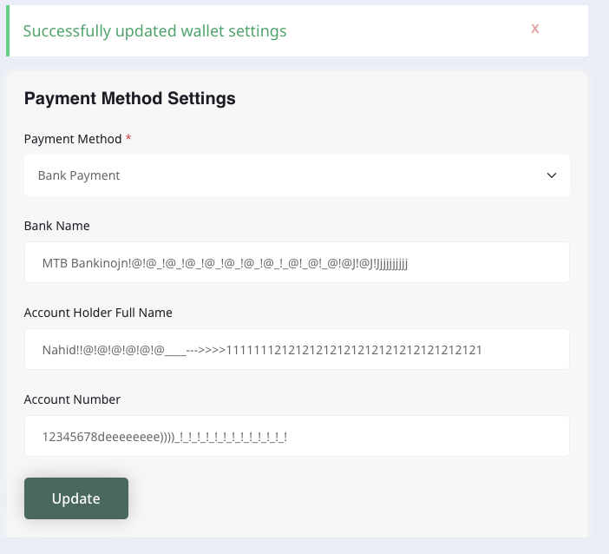

**Bug 23- DEV Comment: SOLVED**

**Location: Wallet Settings**

**Issue:**

1. Special characters allowed
2. Numbers allowed in fields that should not allow it (Account Holder’s Full Name)
3. No character limit

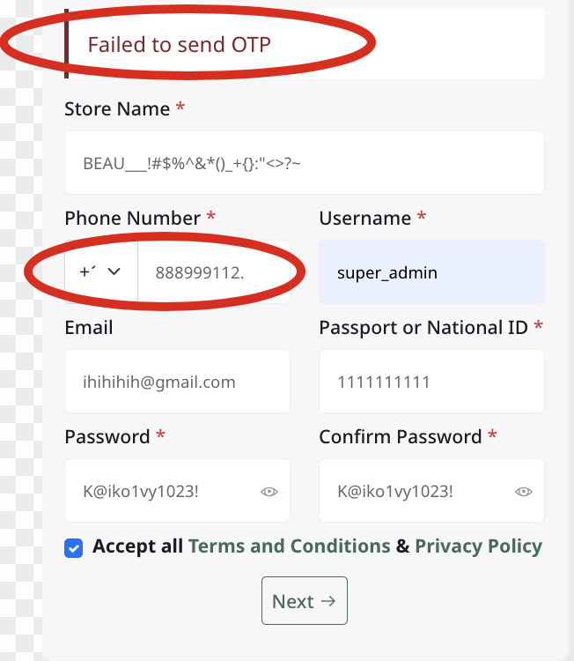

**Bug 24- Check done (dev-nht)**

**Location: Vendor Sign Up**

**Issue:**

1. OTP failure → phone number field allowed a period at the end (no error message was displayed)

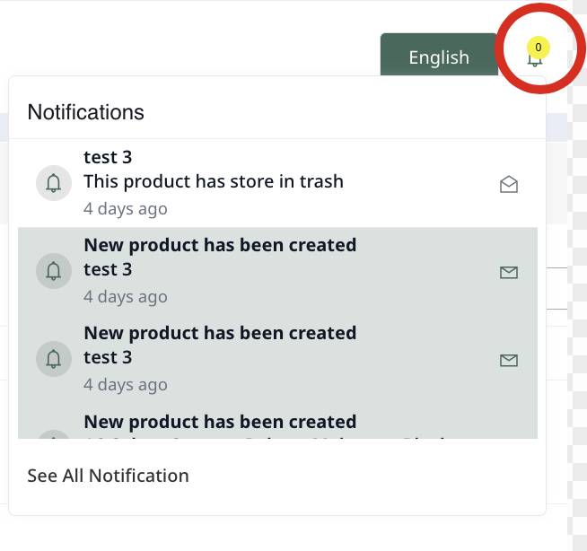

**Bug 25-Checking**

**Location: Vendor Dashboard → Notifications**

**Issue:**

1. The notification counter remains at zero despite there being multiple notifications.

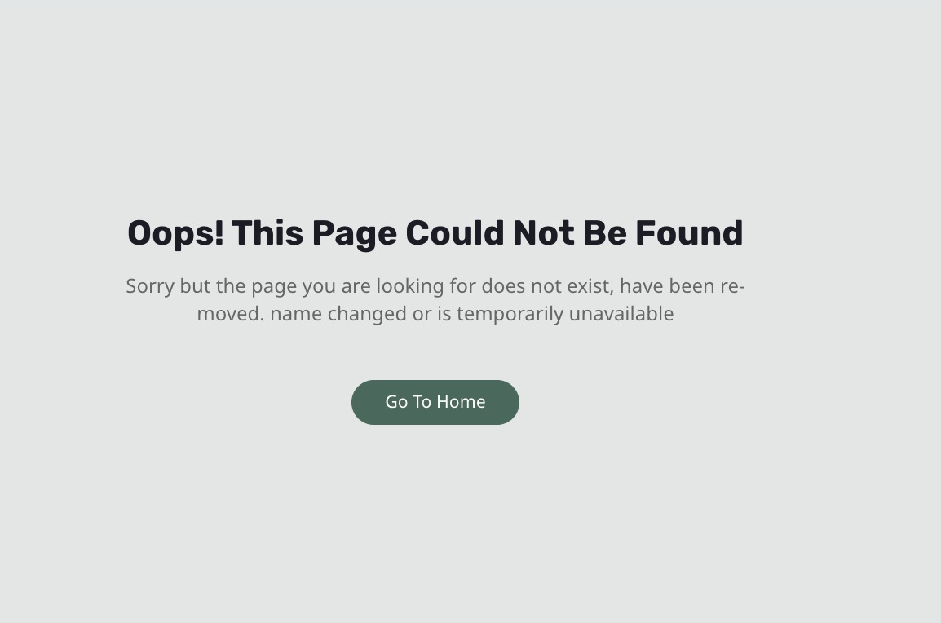

**Bug 26- DEV Comment: SOLVED**

**Location: Vendor Dashboard → Notifications**

**Issue:**

1. Clicking on an individual notification from the notification dropdown leads to an error page.



**Bug 27- DEV Comment: SOLVED**

**Location: Inventory > Click on the edit button of a specific product > under the “Product Inventory” title**

**Issue:**

1. “SKU” should be capitalized



**Bug 28- DEV Comment: SOLVED**

**Location: Products**

**Issue:**

1. “Created At” should be changed to “Created On”



**Bug 29- DEV Comment: SOLVED**

**Location: Products**

**Issue:**

1. “Pending Approval” should be changed to “Pending”



**Bug 30 DEV Comment: SOLVED**

**Location: Products**

**Issue:**

1. “Unpublish” should be changed to “Unpublished”
2. “Publish” should be changed to “Published”
3. “Unpublish” and “Publish” are a verbs



**Bug 31- Check done (dev-nht)**

**Location: Vendor Sign Up**

**Issue:**

1. OTP failure → phone number field allowed a period at the end (no error message was displayed)



**Bug 32-Checking**

**Location: Vendor Dashboard → Notifications**

**Issue:**

1. The notification counter remains at zero despite there being multiple notifications.



**Bug 33- DEV Comment: SOLVED**

**Location: Vendor Dashboard → Notifications**

**Issue:**

1. Clicking on an individual notification from the notification dropdown leads to an error page.



**Bug 34- DEV Comment: SOLVED**

**Location: Inventory > Click on the edit button of a specific product > under the “Product Inventory” title**

**Issue:**

1. “SKU” should be capitalized